Android – Part 8 – Framework Fundamentals

Current 11/10/2011

So far in this course, we have focused on Activity-based coding techniques and navigation of the development environment. A few concepts relating to the Android Application Framework have been mentioned and used, such as Activities, Intents, and callbacks (onCreate(), for example).

In this section we will go into more of this material and establish a basis for a conceptual framework that will help you begin to understand the parts of an Android app, how they work together, and how they interact with the operating system.

Android Components and Terminology

Application Context – the Application Context is an object that contains data and methods that can be used or shared by all application components.
- Extending the Application class in an app (and including it in the manifest file) allows the programmer to add functionality and data that then are available to all components. (Although the doc cited below discourages this.)
- Your code can access this Application-derived object’s data and methods (both inherited and new in your custom class) via
Context context = getApplicationContext();

See http://developer.android.com/reference/android/app/Application.html for more.

Activity – all visible Android programs consist of one or more Activity-derived classes. An Activity is executable code plus a visible screen display.
- Many Android programs consist of multiple Activities (multiple screens) and there are several ways to transfer control from one to another (e.g. Intents).
- It is possible to call an Activity and then receive a returned result from the called Activity when it completes. See startActivityForResult() in the doc cited below.
- Activities go through a number of states during their lifetime and are normally only terminated by the OS when memory is low. See the Activity Life Cycle later in this document.

See http://developer.android.com/reference/android/app/Activity.html for much more.

Service – a Service-derived component consists of executable code but no user interface/screen.
- Typically, Services are used to perform
  - lengthy calculations (factoring large numbers), or
  - background operations (for example, large file transfers or run audio player) or
  - periodic data transfer (possibly in a separate thread of execution) to an Activity for processing and/or display (e.g. weather updates or stock prices).
- Services, like Activities, run on the local device.
- Special techniques may be needed to pass information between an Activity and a Service.
- Services also have a life cycle, which is simpler than that of Activities.
- Services can be part of a project (application) but Services from other applications or stand-alone services can also be called.
A service can essentially take two forms (although it is possible for a single service to be used in both ways):

Started
A service is "started" when an application component (such as an activity) starts it by calling startService(). Once started, a service can run in the background indefinitely, even if the component that started it is destroyed. Usually, a started service performs a single operation and does not return a result to the caller. For example, it might download or upload a file over the network. When the operation is done, the service should stop itself.
Bound
A service is "bound" when an application component binds to it by calling bindService(). A bound service offers a client-server interface that allows components to interact with the service, send requests, get results, and even do so across processes with interprocess communication (IPC). A bound service runs only as long as another application component is bound to it. Multiple components can bind to the service at once, but when all of them unbind, the service is destroyed.
See http://developer.android.com/guide/topics/fundamentals/services.html for more. (The 2 previous paragraphs are from that document.)
Intent – an Intent is a request for transfer of control to another component.
- Some Intents explicitly name the component to be called within the current package (by class name).
- Other Intents identify the component to be called in terms of the capabilities required. These components could be outside the current package. The capabilities are identified by specific named constants (called Intent-filters) externally published and thus known to the programmer.

For more, see http://developer.android.com/reference/android/content/Intent.html

Content Provider – a Content Provider is a data source that implements an interface allowing a client (caller) access to the data via a set of named methods. The actual storage organization of the data (database, list, dictionary, etc.) is hidden from the caller.

Broadcast Receivers – to be added.

Activity Life Cycle

As you know from experience using Android devices, you can only see one Activity at a time on the screen. However, there can be multiple apps (or apps with multiple Activities) active at any time and these non-visible Activities can even be running code. You can think of Activities as being stacked on top of each other, but only the one on top is running its user interface Thread (see Lecture Notes part 9) and can have any interaction with the user. The Android OS manages the transitions among Activities based on code (Intents, etc.) and user actions (the Back button, etc.).
The OS also has the primary role in determining when an app/Activity is terminated and removed from memory. Because launching an Activity is an expensive operation, the OS tries to keep as much of it (and as many Activities) in memory as possible for better responsiveness when a user wants to re-start a recently-used Activity.
In traditional computer applications, a program runs to completion and terminates or a user action terminates the program (in either case it is then removed from memory). In the case of the Android OS, the OS normally has basic responsibility for actual termination and removal from memory, and it does this primarily when memory is low and a newly-launched app needs memory, or the battery is low, or for other reasons known to it. The rationale is that the OS knows best.
(You might see this as analogous to Java’s garbage collection. Memory management used to be the responsibility of programmers, who often made errors that caused program crashes and other difficulties. Automated garbage collection (as in Java) might not be perfect, but it is better.)
In addition to the OS managing what Activity is running, it also manages transitions among several Activity states.
As state transitions occur, the Andriod OS will invoke certain “callback” methods that you can override to perform needed tasks such as starting and stopping threads, obtaining and releasing certain resources, and so on. We have used onCreate() in all our programs so far. The others are:
- protected void onStart()
- protected void onResume()
- protected void onPause()
- protected void onStop()
- protected void onDestroy()

None of these take any arguments. You should call the super class method first in each of these that you override.
The following description of Activity States is summarized from Learning Android by Mark Gargenta (O’Reilly, 2011)
Starting:
- App is not in memory.
- Operations to bring it up are expensive, so the OS tries to minimize the number of times this transition (to running) is done.
- A series of 3 callbacks are executed: onCreate(), onStart() and onResume() before it is up and visible. Note: after onStop() and onRestart(), only onStart() and onResume() are called. See

Running:
- The Activity is in memory, currently visible on the screen, and can accept user input.
- There is only one running Activity at a time.
- The running Activity has priority in getting memory and resources to keep it responsive to user input.

Paused:
- Activity is still visible (but typically very briefly). It may be visible for longer if a pop-up dialog box – or a notification - covers part of the Activity’s screen.
- The Activity cannot receive user input.

Stopped:
- The Activity is not visible but is still in memory.
- It can be brought back to the running state quickly or destroyed by the OS if necessary
- It can run code in this state so it is not really stopped.
- It cannot receive user input.

Dead/Destroyed:
- The Activity has been removed from memory.
- onDestroy() could save data before that, but it might not be called. Better to save data in onPause().

The following diagram is from: http://developer.android.com/reference/android/app/Activity.html and shows the important state paths of an Activity. The square rectangles represent callback methods you can implement to perform operations when the Activity moves between states. The colored ovals are the major states the Activity can be in. (Note: stopped and paused states are not explicitly shown.)
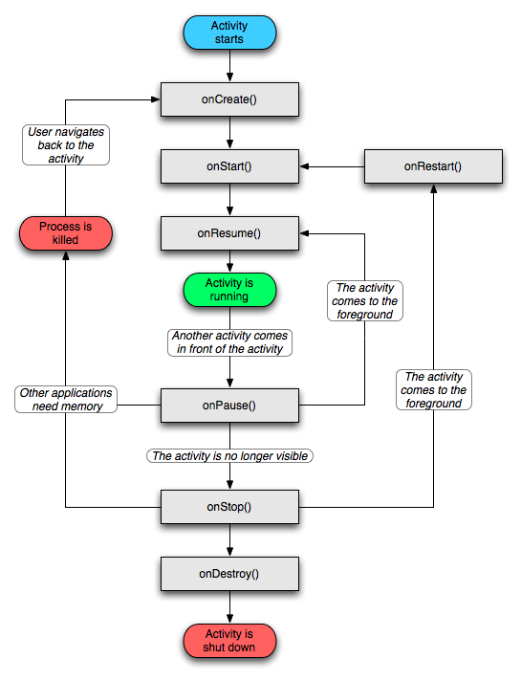
The Flowchart on the previous page can be expressed (with a few more details) in a table as follows:
State | Visible in this state? | Possible transitions to: | Visible after transition | Callbacks during transition | Possible action causing transition
Not running; not loaded = Dead | No | Running | Yes | onCreate()  onStart()  onResume() | User starts app or restarts Activity from Stopped
Running | Yes | Paused | No or partly (dialog) | onPause() | Another Activity comes to top (Ex: Back btn; dialog; notification
Paused | Partly (dialog) or not visible | Running  Stopped  Killed | Yes  No  No | onResume()  onStop()  process killed | Dialog closes
Stopped | No | Running  Process killed  Dead | Yes  No  No | onRestart, etc.  onCreate() etc.  onDestroy() | Back btn brings Act. to foreground  OS needs memory  Low battery; shutdown
Dead | No

Note: the Bundle argument is passed to onCreate() – if saved in onStop() – if the Activity process is stopped and then brought to the top again. The other callback methods have no arguments.
In order to gain a working understanding of how this actually works, it is helpful to take a working app with several Activities and create stub callback methods for each of them. Create a unique TAG string for each Activity and then paste in the following:
@Override
public void onCreate(Bundle savedInstanceState) {
super.onCreate(savedInstanceState);
setContentView(R.layout.whatever);
Log.i(TAG, "in onCreate");
// add in whatever you would normally include here
}
@Override
public void onStart() {
super.onStart();
Log.i(TAG, "in onStart");
}
@Override
public void onRestart() {
super.onRestart();
Log.i(TAG, "in onRestart");
}
@Override
public void onResume() {
super.onResume();
Log.i(TAG, "in onResume");
}
@Override
public void onPause() {
super.onPause();
Log.i(TAG, "in onPause");
}
@Override
public void onStop() {
super.onStop();
Log.i(TAG, "in onStop");
}
@Override
public void onDestroy() {
super.onDestroy();
Log.i(TAG, "in onDestroy");
}

Now in the LogCat Console, create a filter name such as “Callback” and Log level “info” (corresponding to Log.i calls).

