BANANAS กล้วย
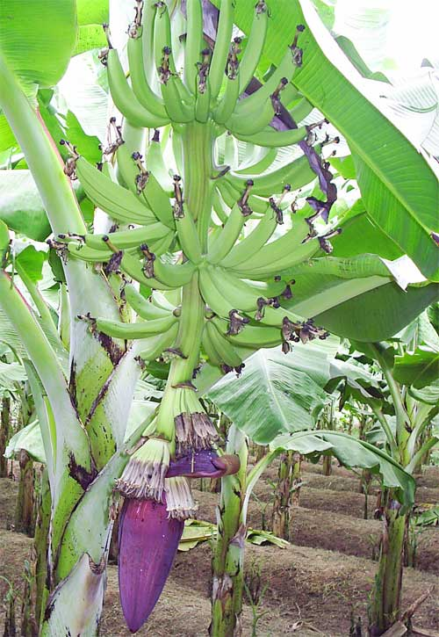 | Growth Habit: Bananas are fast-growing herbaceous perennials arising from underground rhizomes. The fleshy stalks or pseudostems (หน่อ) formed by upright concentric layers of leaf sheaths constitute the functional trunks. The true stem ( เหง้า ) begins as an underground corm which grows upwards, pushing its way out through the center of the stalk 10-15 months after planting, eventually producing the terminal inflorescence which will later bear the fruit. Each stalk produces one huge flower cluster and then dies. New stalks then grow from the rhizome. Banana plants are extremely decorative, ranking next to palm trees for the tropical feeling they lend to the landscape.
Foliage: The large oblong or elliptic leaf blades are extensions of the sheaths of the pseudostem and are joined to them by fleshy, deeply grooved, short petioles. The leaves unfurl, as the plant grows, at the rate of one per week in warm weather, and extend upward and outward , becoming as much as 9 feet long and 2 feet wide. They may be entirely green, green with maroon splotches, or green on the upper side and red-purple beneath. The leaf veins run from the mid-rib straight to the outer edge of the leaf. Even when the wind shreds the leaf, the veins are still able to function. Approximately 44 leaves will appear before the inflorescence. | 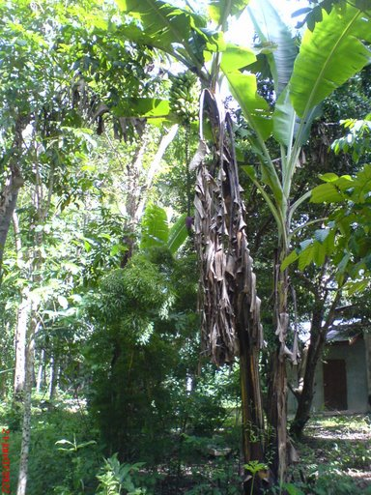
 | Flowers( หัวปลี ): The banana inflorescence shooting out from the heart in the tip of the stem, is at first a large, long-oval, tapering, purple-clad bud. As it opens, the slim, nectar-rich, tubular, toothed, white flowers appear. They are clustered in whorled double rows along the floral stalk, each cluster covered by a thick, waxy, hood like bract, purple outside and deep red within. The flowers occupying the first 5 - 15 rows are female. As the rachis of the inflorescence continues to elongate, sterile flowers with abortive male and female parts appear, followed by normal staminate ones with abortive ovaries. The two latter flower types eventually drop in most edible bananas.
Fruits: The ovaries contained in the first (female) flowers grow rapidly, developing parthenocarpically (without pollination) into clusters of fruits, called hands. The number of hands varies with the species and variety. The fruit (technically a berry) turns from deep green to yellow or red, and may range from 2-1/2 to 12 inches in length and 3/4 to 2 inches in width. The flesh, ivory-white to yellow or salmon-yellow, may be firm, astringent, even gummy with latex when unripe, turning tender and slippery, or soft and mellow or rather dry and mealy or starchy when ripe. The flavor may be mild and sweet or subacid with a distinct apple tone. The common cultivated types are generally seedless with just vestiges of ovules visible as brown specks. Occasionally, cross-pollination with wild types will result in a number of seeds in a normally seedless variety. | 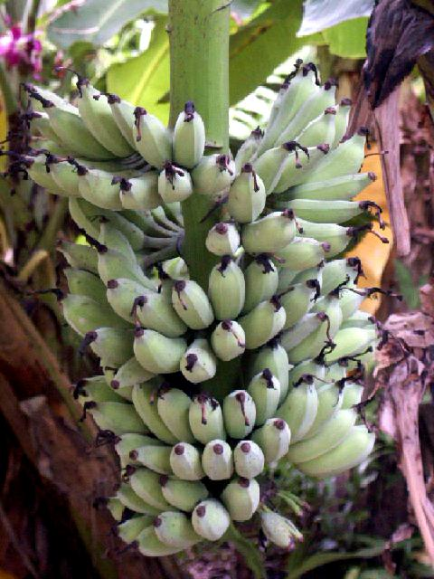
[Source: http://www.crfg.org/pubs/ff/banana.html]
Thai Bananas
There are many kinds of Thai bananas. The banana variety that is most popular in the U.S. is called kluay hawm กล้วยหอม or “fragrant banana.”
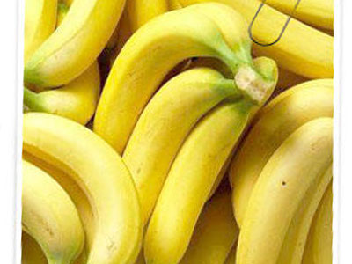  กล้วยหอม | 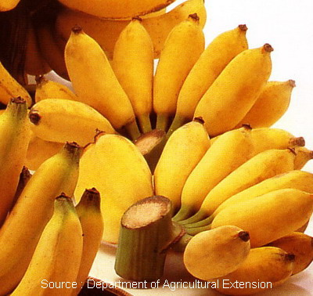  กล้วยน้ำว้า
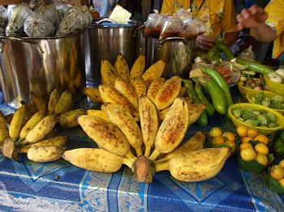  กล้วยหักมุก | 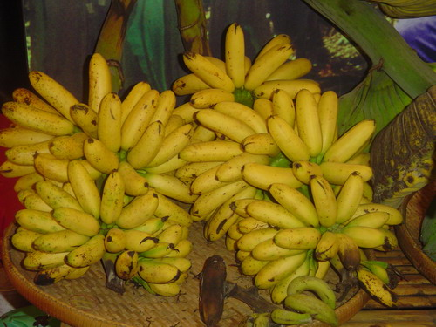  กล้วยไข่
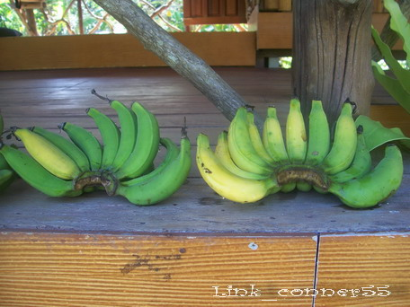
กล้วยเล็บมือนาง

Recipe for Thai Banana Dessert

กล้วยบวดชี
(nun’s banana)
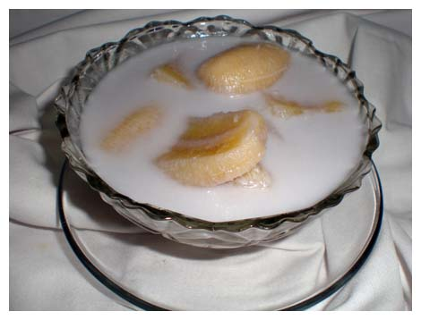
ส่วนผสม  กล้วยน้ำว้า (ห่าม) ๑๒ ลูก  กะทิ ๑ กิโลกรัม  หัวกะทิ ๒๐๐ กรัม  น้ำตาลทราย ๒๐๐ กรัม  เกลือ ๕ กรัม | Ingredients :  12 bananas ( half ripe )  1 lt. coconut milk  200 ml. condense coconut milk  200 g. caster sugar  5 g. salt
วิธีทำ  - ปอกกล้วย หั่น ๔ ชิ้น  - ละลาย น้ำตาลทราย และเกลือ ในกะทิ  - ต้มกะทิ พอเริ่มเดือด ใส่กล้วย ต้มต่อจนเดือด และ กล้วยสุก  - ใส่หัวกะทิ ต้มให้เดือด อีกครั้ง | Method :  - Peel bananas, make into quarters.  - Dissolve sugar and salt into coconut milk.  - Heat 2. , when start boiling, put bananas, bring to boil and bananas is cooked.  - Put condense coconut milk into 3. , bring to boil again.

Source : http://www.horapa.com

